Anadarko Community Library – City of Anadarko
Hollytex Community Room Reservation and Rental Agreement
Reservation Information
Date of Use: _________________ Start Time: _____________ End Time: ____________ Number of Hours: _______
Reserved By: ___________________________________________
Billing Street Address: ___________________________________________
City, State, Zip: ___________________________________________
Primary Telephone Number: _______________________ Secondary Telephone Number: _____________________
Anadarko Community Library Business Hours
Monday – Friday 8:00 a.m. to 5:00 pm

Signature of Renter: ______________________________________ Date Rented: ________________________
Signature of City of Anadarko Representative: __________________________ Date: _________________________
Date Collected | Business Hour Pricing | Date Collected | After Business Hour Pricing
 | $25.00 Refundable Deposit |  | $25.00 Refundable Deposit
 | $50.00 Use Fee Up to 4 hours |  | $75.00 Use Fee – Up to 4 hours
 | $100.00 Use Fee – Up to 8 hours |  | $125.00 Use Fee – Up to 8 hours
 | $25.00 Table and Chair Setup |  | $25.00 Table and Chair Setup
 | $25.00 Refreshment Setup – 3 packs coffee, creamer, sugar, artificial sweetener, stir sticks, cups, and ice water for up to 30 people |  | $25.00 Refreshment Setup – 3 packs coffee, creamer, sugar, artificial sweetener, stir sticks, cups, and ice water for up to 30 people
POLICY AND SIGNATURE AGREEMENT FOR ROOM AND/OR EQUIPMENT RENTAL
Community groups are encouraged to use the meeting room facilities at the Anadarko Community Library for educational, cultural, and civic purposes.

Fees and Charges:
- All fees must be paid at time of reservation to secure time and date.
  - Cancellations must be made 72-hours in advance for a refund of usage, setup, or refreshment fees. Deposits will not be refunded with cancelations. Cancellations not made within 72-hours in advance of the scheduled event will not be refunded.
- All refunds will be mailed to the customer by the City of Anadarko if the room and/or equipment is left clean and not damaged within 7 business days.
- A copy of the signed reservation form with the community room policy has been provided to the customer.
Community Room Scheduling:
- When planning your meeting/activity, scheduling needs to allow time for cleaning and vacating the premises.
- The meeting room is not available after 9:00 P.M., Sunday, or holidays.
- Library programs and related activities are given priority, should scheduling conflicts arise.
- No library program will be planned for a reserved time after a reservation has been confirmed by the staff.
- The library will not accept reservations for a series of meetings which would designate the library as their regular meeting place for an organization, except groups specifically sponsored or organized by the library.
- The Library will not accept reservations for Religious, Political, Social Groups, or for profit-events unless sponsored by the library.
- Groups may reserve the library meeting rooms for one meeting at a time for up to six months in advance.
- Requests for the use of the facilities should be made with the staff, Monday through Saturday during regular library hours.
- No one under twenty-one (21) years of age may reserve the room.
- Patron scheduling use of the room MUST be on time to take possession of the community room within 15 minutes of start time or patron will default on this agreement the community room will be closed, library staff will consider and document it as a no show and no refund will be given for any default.
Community Room Use:
- Activities for minors must be sponsored by at least one person over 21 years of age.
- The use of the facilities by an organization does not necessarily constitute an endorsement of that organization's policies or beliefs.
- Smoking, the use of tobacco, or the use of alcoholic beverages is not allowed anywhere in the library or in its meeting rooms.
- Sponsoring groups are responsible for setting up the Room to meet their needs and are responsible for ensuring reasonable order by group members or others attending the meeting.
- Simple decorations may be set up in the room for a meeting or exhibit, but no decorations may be hung which will mar the walls, floors or ceilings i.e., tape, staples, thumb tacks. Any decoration or exhibits must be removed by the group using them.
- Activities involving more than normal wear and tear on the community room or contents should be avoided.
- The library reserves the right, for adequate reasons, to revoke permission to use the meeting room.
- Groups are responsible for exercising reasonable care in the use of refreshments, the care of the facility, and the disposal of food and refuse.
- Any lost or damaged furniture or equipment becomes the responsibility of the sponsoring group.
- Groups are responsible for maintaining the room in a clean and orderly manner. Countertops must be wiped clean, trash taken to the dumpster outside, floors must be swept and mopped as needed, tables and chairs must be cleaned and furniture must be put back into original position, tables are to be put back on the table rack and chairs are to be stacked against the south wall.
- Use of the Community Room shall not be allowed on Sundays or on any holiday during which the Library is closed.
Community Room/Library Equipment Use:
- The Library has a Video Conferencing System, Television, DVD Player, Projection Screen, and Projector available for checkout via library card for during business hour use only.
- Library equipment may be checked out for your meeting by library staff during library hours prior to your meeting – These items are not available for after hour usage.
- All equipment will be returned to library staff and checked in.
- The party checking out Library equipment agrees and understands that they will be responsible for the cost of any item that is lost, stolen, or damaged.

Equipment Requested:
 | Tables |  | Chairs | 2 | Coffee Pot (30 cup) | 1 | Microwave
1 | Media Table |  | Small Trash Can | 1 | Glass Cleaner | 1 | Dust Mop
1 | 4 Small & 2 Large Trash Bag | 1 | 55 Gallon Trash Can | 1 | Broom and Dust Pan |  | Library Dumpster Unlocked
1 | Disinfectant Cleaner | 1 | Paper Towel Roll | 1 | Mop Bucket and Mop |  | Bathroom Keys (after hours)
 | Table and Chair Setup (Fees Apply) |  | Refreshment Setup (Fees Apply) | 1 | Toaster Oven | 1 | 2 burner cook top

Community Room Rental Agreement:
By signing this agreement; I have read and understand the community room policy and I agree to adhere to all policies. I agree to be responsible for leaving the meeting room clean and ready for the next use. If the room is not left in clean and/or undamaged condition I will not receive a refund of your cleaning deposit. I understand that I must take possession of the room within 15 minutes of the agreed start time on this form or the rental agreement will default/No Show and the library staff will close the room with no refund given for any default and or no show. I understand that any refund will be sent to me by the City of Anadarko.

Printed Name: _______________________ Signature: ________________________ Date: _______________________

Library Director Signature: _________________________________ Date: ________________________

Table & Chair Setup Options: $25.00 Fee for Setup – Person reserving the room is responsible for cleaning and breaking down the tables and chairs after the event.
Option 1 Seats 33 with one presenter table and seat
Option 2 Seats 24 with two presenter tables and seats
Option 3 Seats 60 with one presenter podium
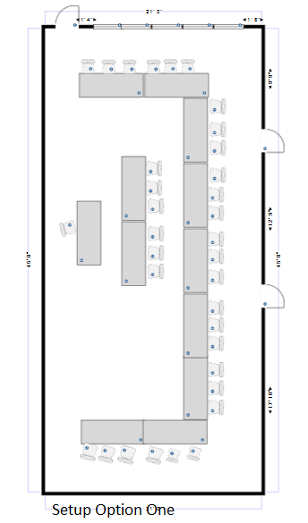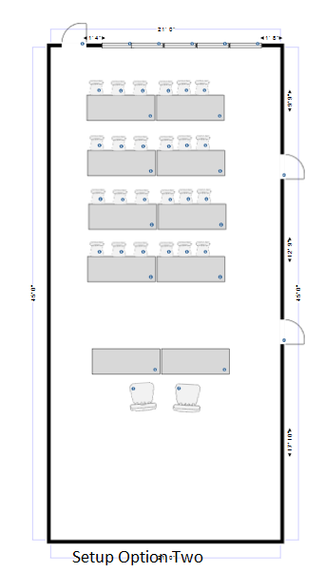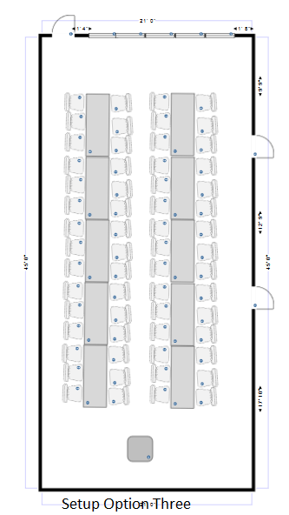

Anadarko Community Library HollyTex Community Room Check-out:
Please ensure to call Janis Kindred at (405) 247-7351 or (405) 933-3836 if after hours, prior to leaving the community room to ensure the room is properly locked and all equipment is checked in. You will be responsible for any damages if the room is left unattended for any reason.
Equipment Checked Out
 | Tables |  | Chairs | 2 | Coffee Pot (30 cup) | 1 | Microwave
1 | Media Table |  | Small Trash Can | 1 | Glass Cleaner | 1 | Dust Mop
1 | 4 Small & 2 Large Trash Bag | 1 | 55 Gallon Trash Can | 1 | Broom and Dust Pan |  | Library Dumpster Unlocked
1 | Disinfectant Cleaner | 1 | Paper Towel Roll | 1 | Mop Bucket and Mop |  | Bathroom Keys (after hours)
 |  |  |  | 1 | Toaster Oven | 1 | 2 burner cook top
 | Community Room Clean |  | Tables Cleaned |  | Tables Stacked on Rack |  | Chairs stacked Neatly
 | Men’s bathroom Clean |  | Women’s Bathroom Clean |  | Hall Way Clean |  | Kitchen Clean
 | Table and Chair Setup cleaned up |  | Refreshment Setup  Cleaned up

By signing this agreement; you agree to be held responsible for the cost of any item that is lost, stolen, or damaged.
Patron
Printed Name: ______________________ Signature: ______________________ Date: __________________

Library Staff Authorizing Agreement:
Printed Name: ______________________ Signature: ______________________ Date: ___________________

Anadarko Community Library HollyTex Community Room Check-in:

Please ensure to call Janis Kindred at (405) 247-7351 or (405) 933-3836 if after hours, prior to leaving the community room to ensure the room is properly locked and all equipment is checked in. You will be responsible for any damages if the room is left unattended for any reason.

When checking in, please make sure all tables are cleaned off with disinfectant spray and put away on the table rack, chairs are stacked neatly against the wall, counter tops in the kitchen are wiped down, coffee pot and microwave cleaned if used, and floors are swept and mopped as needed. Trash can be put in the library dumpster directly behind the library. Anything moved MUST be placed back as it was when you checked into the room.
Equipment Checked In
 | Tables |  | Chairs | 2 | Coffee Pot (30 cup) | 1 | Microwave
1 | Media Table |  | Small Trash Can | 1 | Glass Cleaner | 1 | Dust Mop
1 | 4 Small & 2 Large Trash Bag | 1 | 55 Gallon Trash Can | 1 | Broom and Dust Pan |  | Library Dumpster Unlocked
1 | Disinfectant Cleaner | 1 | Paper Towel Roll | 1 | Mop Bucket and Mop |  | Bathroom Keys (after hours)
 |  |  |  | 1 | Toaster Oven | 1 | 2 burner cook top
 | Community Room Clean |  | Tables Cleaned |  | Tables Stacked on Rack |  | Chairs stacked Neatly
 | Men’s bathroom Clean |  | Women’s Bathroom Clean |  | Hall Way Clean |  | Kitchen Clean
 | Table and Chair Setup cleaned up |  | Refreshment Setup  Cleaned up

Patron
Printed Name: ________________________ Signature: ______________________ Date: ________________

Library Staff Authorizing Agreement:

Printed Name: ________________________ Signature: ______________________ Date: ________________

Deposit Returnable: Yes / No
If No, please explain?
______________________________________________________________________________________________________________________________________________________________________________________________________________________________________________________________________________________________________________________________________________________________________________________________________________________________________________________________________

